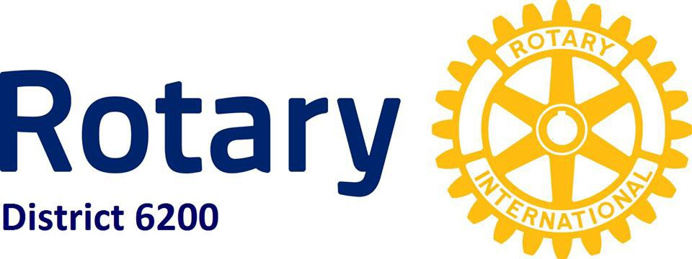
Application
Rotary Youth Leadership Award
Must be submitted by May 1st

June 6 - June 9, 2019 - Bayou Segnette State Park 7777 Westbank Expy, Westwego, LA 70094

Club RYLA Chairperson Information:
Sponsoring Rotary Club Click here to enter text.
RYLA Club Chairperson Click here to enter text.
Email Click here to enter text.

(PLEASE TYPE OR PRINT CLEARLY, UNREADABLE APPLICATIONS WILL BE REJECTED)

Applicant’s Full Name Click here to enter text.
Mailing Address Click here to enter text.
City Click here to enter text. State Click here to enter text. Zip Code Click here to enter text. Grade Click here to enter text. Age Click here to enter text. GPA Click here to enter text.
School Attended Click here to enter text.
Email Click here to enter text. T-Shirt Size Click here to enter text.
Home Phone Click here to enter text. Mobile Click here to enter text.
Emergency Daytime Phone Click here to enter text.

ACADEMIC ACCOMPLISHMENTS: (Honor Roll, Awards, Accelerated/Special Classes)

Click here to enter text.

OTHER SCHOOL ACTIVITIES AND RECOGNITIONS: (Positions held and responsibilities undertaken)
Click here to enter text.
SPORTS PARTICIPATION: (Number of years. levels of competition and honors)

Click here to enter text.

OUTSIDE SCHOOL INTEREST, SERVICE ACTIVITIES, HOBBIES AND RECREATION

Click here to enter text.

WORK EXPERIENCE: ( Summers and After School)

Click here to enter text.

OPTIONAL: (Write a short essay on why you think the Rotary Youth Leadership Award will be a good experience for you.)

Click here to enter text.

APPLICATIONS MUST BE SIGNED AND HAVE A CURRENT PHOTO ATTACHED.
PARENTS
SIGNATURE DATE

